A WEB-BASED
FINAL YEAR PROJECT MANAGEMENT SYSTEM
CASE STUDY: BUSITEMA UNIVERSITY

By

KITARA EMMANUEL OKELLO
BU/UP/2023/1495
+256758227302
ekitara22@gmail.com
Department of Computer Studies
Faculty of Science and Education.

A Project Proposal Submitted to the Faculty of Science and Education
For the Study leading to a Project in Partial Fulfilment of the Requirements for the Award of the Degree of Bachelor of Information Technology
Busitema University.

Supervisors: Dr. Nandutu Irene & Mr. Wambi Fred
+256757806822 / +256707878805
inandutu.sci@busitema.ac.ug / wambifred@76gmail.com
Department of Computer Studies
Faculty of Science and Education, Busitema University.

OCTOBER, 2025.

Chapter One: Introduction

Background of the Study
Final Year Projects (FYPs) are a core academic requirement in most universities and serve as a capstone for assessing students’ ability to apply theoretical knowledge to real-world problems. Through final year projects, students demonstrate research competence, problem-solving skills, innovation, and technical proficiency acquired during the course of study. Effective management of final year projects is therefore essential for maintaining academic quality and institutional accountability.
Traditionally, the management of final year projects in many higher learning institutions has relied on manual and semi-manual approaches such as paper-based proposal submissions, physical logbooks, email-based supervision, and manual allocation of supervisors. In most universities and colleges, students’ proposals and reports were collected, processed, and summarised using paper-based portfolios, a process that was time-consuming, inefficient, and disorganised (Suharno and Imraan, 2024). Supervisors often handle multiple students concurrently, progress tracking is done manually, and communication between students and supervisors is inconsistent. These practices frequently lead to delayed feedback, poor documentation, duplication of project topics, loss or misplacement of records, and limited transparency in supervision and assessment (Haruna et al., 2023).
With rapid advancements in Information and Communication Technologies (ICT), information has become more accessible and easier to manage. Educational institutions, as centres of knowledge creation and dissemination, are increasingly expected to adopt automated information systems to enhance academic administration and decision-making (Ahmad, 2024). Information systems enable institutions to efficiently collect, store, process, and disseminate data, thereby improving coordination, accountability, and service delivery (Masruri, 2025). Within the education sector, Educational Management Information Systems (EMIS) have been widely adopted to support academic planning, monitoring, evaluation, and evidence-based decision-making and institutional planning (Kebebe and Regassa, 2024).
Computers and electronic communication technologies play a vital role in ensuring faster flow of information in the rapidly developing world (Geymen et al., 2008). The computerised environment supports timely access to information, efficient record management, and improved communication among stakeholders (Durkaya and Durkaya, 2003). Final Year Project Management Systems form part of this broader shift towards automation in higher education institutions.
A Final Year Project Management System (FYPMS) is an automated web-based platform designed to manage the entire lifecycle of students’ final year projects, from topic proposal and supervisor allocation to progress tracking, assessment, grading, and archival of completed projects. The system facilitates structured supervision, timely feedback, approval of proposals and reports, and secure storage of academic records, while also providing a centralised repository for final year projects and reports. Such systems enhance efficiency, transparency, and effective communication among students, supervisors, and administrators.
Final year project submission is a recurring academic activity in most universities and continues to receive increasing attention as institutions are required to demonstrate accountability, performance, and efficiency to stakeholders. Designing an effective final year project management system involves integrating multiple users, workflows and evaluation mechanisms into a secure digital environment (Sabo et al., 2025).
At Busitema University, the management of final year projects is still largely manual, presenting significant challenges in monitoring student progress, coordinating supervision, analysing submissions, and maintaining accurate project records. Manual paper-based systems are prone to data loss, omission of records, and delays in analysis and decision-making. This situation necessitates the development of an automated Final Year Project Management System to streamline project registration, supervision, evaluation, and report submission, thereby improving efficiency and effectiveness in the management of final year projects.

Problem Statement
The management of final year projects plays a critical role in supporting effective learning, research supervision, and institutional development within universities (Uttl, White and Gonzalez, 2017). However, the absence of an integrated and automated system for managing final year projects at Busitema University has resulted in several operational challenges. These include delays in project proposal approvals, poor communication between students and supervisors, difficulty in tracking project milestones, and loss or duplication of project documents.
Currently, Busitema University–Nagongera Campus relies on a rudimentary, paper-based approach to manage final year projects. This manual system makes the retrieval, storage, and maintenance of project information difficult and inefficient. Supervisors and administrators are required to handle proposals, progress reports, and final submissions manually, a process that is time-consuming and prone to errors. As a result, analysing project data, monitoring student progress, and generating timely reports for decision-making and quality assurance becomes challenging.
Furthermore, the extensive paperwork involved in submitting proposals, reports, and feedback significantly delays the supervision and evaluation process. The lack of a centralised platform limits transparency, weakens coordination among stakeholders, and hinders effective documentation and archiving of final year projects.
Therefore, there is a need to design and develop an automated, web-based Final Year Project Management System to streamline project registration, supervision, progress tracking, evaluation, and documentation. Such a system will enhance efficiency, improve supervision, ensure proper record management, and support effective administration of final year projects at Busitema University.

Main Objective
The main goal of the study is to develop and design an automated Final Year Project Management System (FYPMS) that supports efficient management, monitoring, and evaluation of students’ final year projects at Busitema University.

Specific objectives of the project include the following;
- To review the literature and determine the requirements of the Final Year Project Management System.
- To design an automated web-based Final Year Project Management System.
- To implement an automated web-based Final Year Project Management System.
- To test and validate the automated web-based Final Year Project Management System.

Significance of the Study
Upon the successful development and implementation of the automated web-based Final Year Project Management System, the study is expected to yield the following benefits:
- Improved efficiency: The system will streamline project proposal submission, supervision, progress tracking, and assessment, thereby reduce delays and improve overall project management efficiency.
- Enhanced communication: The system will facilitate effective and timely communication among students, supervisors, and administrators through a centralized platform.
- Centralised and secure data management: It will provide a secure and centralised repository for storing final year project proposals, reports, and related documents, minimizing the risk of data loss or duplication.
- Support for timely decision-making: Automated reporting and tracking features will enable administrators and supervisors to generate real-time reports to support informed decision-making and quality assurance.
- Reduced administrative workload: By minimizing paperwork and manual handling of documents, the system will significantly reduce administrative workload and operational costs.

Scope of the Study

Area scope
The area scope defines the geographical boundary within which the study will be conducted and from which data will be collected for the system design and development.
This study shall be carried out at Busitema University-Nagongera Campus located Nagongera Town Council in Tororo District about 17 kilometres from Tororo town along Tororo-Busolwe road.

Content Scope
The content scope of the study focuses on the design and development of a web-based Final Year Project Management System (FYPMS) to support the management of final year projects at Busitema University.
The system will support multiple user roles, including students, supervisors, and administrators. Core functionalities of the system will include project topic submission, supervisor allocation, proposal and report submission, progress and milestone tracking, document upload, feedback provision, approval and rejection of submissions, and automated report generation. The system will utilize modern web-based technologies with a centralized database for secure data storage and retrieval. It will also analyse technological solutions that can be integrated into the FYPMS to enhance efficiency, learning outcomes, and user experience.
Administrators will be responsible for system management tasks such as user registration, supervisor allocation, milestone tracking, approvals, and overall system monitoring. Students will be responsible for logging into the system, submitting project proposals and reports, and tracking project progress. Supervisors will review submissions, provide feedback, and approve or reject milestones and reports.
In addition, the study will examine best practices in the implementation of Final Year Project Management Systems from other educational institutions and organisations. Particular attention will be given to the effectiveness of existing FYPMS tools, identification of gaps in user engagement, and the potential benefits of a centralized platform for managing learning and assessment processes.

Time scope
This study will be carried out over a period of five (5) months from 17th October, 2025 to 28th February, 2026.

Chapter Two: Literature Review

Introduction
This chapter presents a critical review of existing literature related to information systems, management information systems, educational management information systems, and project management systems within higher education. The purpose of this review is to establish a theoretical and empirical foundation for the design and development of the proposed Final Year Project Management System (FYPMS). The chapter also examines challenges associated with manual project management approaches and highlights the benefits of automated systems in managing final year projects.

Information Systems
An information system is a combination of people, hardware, software, data, and procedures that interact to collect, process, store, and disseminate information in order to support decision-making, coordination, and control within an organization (Masruri, 2025). Information systems are essential in improving organizational efficiency, reducing operational costs, and enhancing accuracy in data handling.
In higher education institutions, information systems are widely used to manage academic records, student information, course administration, and institutional reporting. The adoption of information systems enables universities to automate routine processes, improve access to information, and support evidence-based decision-making (Haruna et al., 2023). The proposed Final Year Project Management System is grounded in information system principles, as it seeks to integrate people, processes, and technology to manage final year project activities efficiently.

Management Information Systems(MIS)
Management Information Systems (MIS) are a subset of information systems designed to provide managers with timely, accurate, and relevant information to support planning, monitoring, and decision-making (Ahmad, 2024). MIS typically generate structured reports based on data collected from transaction processing systems.
In academic institutions, MIS play a significant role in monitoring student performance, managing academic activities, allocating resources, and evaluating institutional performance. MIS enable administrators to track academic progress, identify challenges, and make informed decisions that improve institutional effectiveness. A Final Year Project Management System can be considered a specialized academic MIS, as it supports the management and monitoring of student research projects, supervision activities, and assessment outcomes.

Educational Management Information System (EMIS)
Educational Management Information Systems (EMIS) support planning, monitoring and evaluation in educational institutions. Research shows that EMIS implementation improves accountability, transparency and institutional coordination (Kebebe and Regassa, 2024). Furthermore, Masruri(2025) argues that EMIS frameworks optimise learning processes by enabling efficient data collection analysis.
In Uganda, the Ministry of Education and Sports (MoES) utilizes EMIS to facilitate evidence-based decision-making, policy formulation, and monitoring of educational performance at various levels (MoES, n.d.). EMIS have improved data accessibility, accountability, and transparency in the education sector.
Final Year Project Management Systems can be viewed as components or extensions of EMIS, as they focus on managing a specific but critical academic process—final year projects. By integrating FYPMS into institutional information systems, universities can enhance monitoring of student research activities, improve supervision quality, and maintain reliable academic records.

Project Management Systems in Higher Education
Project Management Systems provide tools for planning, scheduling, monitoring, and controlling project activities. In higher education, automated project management systems have increasingly been adopted to manage student research projects, including final year projects (Suharno and Imraan, 2024). These systems facilitate structured supervision, timely feedback, and systematic documentation of project activities.
A Final Year Project Management System typically supports functionalities such as project topic submission, supervisor allocation, milestone tracking, proposal and report submission, feedback provision, grading, and archival of completed projects. Such systems enhance transparency, accountability, and collaboration among students, supervisors, and administrators.
According to Haruna et al., (2023), web-based academic management systems significantly improve communication and reduce administrative delays by providing a centralized platform for interaction and documentation. This makes automated FYPMS particularly suitable for institutions with large student populations and limited administrative resources.

Challenges of the Manual Project Management
Despite the importance of final year projects, many universities continue to rely on manual or paper-based systems to manage project activities. Manual project management systems are associated with poor documentation, delayed feedback and inefficient record retrieval (Ahmad, 2024). The absence of secure digital workflows may also lead to data inconsistencies and limited accountability (Sabo et al., 2025).
Paper-based systems are prone to data loss, duplication of project topics, inconsistency in documentation, and difficulty in retrieving historical records. Supervisors handling multiple students often struggle to track individual progress effectively, while administrators face challenges in generating timely reports for quality assurance and decision-making. These inefficiencies negatively affect the quality of supervision and overall student learning experience.

Benefits Of an Automated Final Year Project Management System
Automated Final Year Project Management Systems offer numerous advantages over manual approaches. These include improved accuracy of records, real-time access to project information, enhanced communication among stakeholders, secure storage of documents, and efficient reporting mechanisms (Alruwais, Wills and Wald, 2018).
Electronic systems allow students and supervisors to interact through a centralized platform, reducing delays and improving transparency. Automated tracking of milestones and submissions ensures timely completion of projects and enables administrators to monitor progress effectively. Studies indicate that students and academic staff prefer electronic systems due to their convenience, flexibility, and reliability (Alruwais et al., 2018).
By adopting an automated FYPMS, universities can improve supervision quality, reduce administrative burden, and enhance the overall effectiveness of final year project management.

Chapter Three: Methodology

Introduction
This chapter describes the methods that shall be used to achieve the objectives of the study. It describes how data shall be collected using literature review, interviews, observation, focus groups and how collected data will be analysed to aid the system development.
The method chosen for data collected of this project is qualitative, which is often the best and most efficient approach of collecting complete information from the small population and host mouth of the administrator. Qualitative methods are for conducting researches that rely on open ended exploration of people’s action, words, thoughts and intentions. Qualitative methods include observation, focus groups and interviews.

Area of Study
The study will be conducted at Busitema University, situated along the Tororo-Busolwe road in Nagongera Town Council, 17 kilometres from Tororo Town in Tororo District, Eastern Uganda. The institution has been selected due to its strong commitment to academic excellence and innovation, as well as its diverse student population drawn from multiple regions
The research will focus on examining the university’s current final year project (FYP) processes, which are predominantly managed through traditional, face-to-face interactions. These processes include tracking project milestones, delivering academic content, assigning supervisors, obtaining approvals, and providing feedback on project progress. Currently, these activities are largely manual, which can lead to inefficiencies, delays, and inconsistencies.
This context presents an ideal opportunity to assess the limitations of the existing system and to explore how a Final Year Project Management System (FYPMS) could improve educational delivery and student engagement. By digitizing key project management tasks, the system aims to streamline processes, enhance communication between students and supervisors, and provide a more efficient, transparent, and user-friendly approach to managing final year projects.

Population and Sampling
The population of a study refers to the complete set of individuals, items, or elements from which data can be collected, while sampling is the process of selecting a subset of elements from this population to participate in the study. The number and characteristics of participants are determined by the purpose and scope of the research. Participants can be categorized by factors such as employment title, age, gender, or other relevant criteria to ensure the study captures diverse perspectives.
For this study, the population consists of students, lecturers, and faculty administrators at Busitema University who are directly involved in the final year project processes. The research will involve a total of eleven (11) male and nine (9) female participants, including three lecturers and one faculty administrator. These participants are considered key stakeholders within the current learning environment and can provide valuable insights into the limitations of the existing system and requirements for the proposed Final Year Project Management System (FYPMS).

Table: Sample Size of Participants
Participants | Male | Female
Administrator | 1 | -
Lecturers | 1 | 2
Students | 9 | 7
Total | 11 | 9
Table 1: Participants’ table
A simple random sampling method will be used to select participants from the student population, ensuring that every eligible individual has an equal chance of being included. In addition, a non-probability sampling technique, specifically convenience sampling, will be applied for selecting lecturers and the faculty administrator based on their availability and willingness to participate. This approach is expected to yield timely and relevant feedback to guide the design and development of the FYPMS.

System Development Methodology
The development of the proposed Final Year Project Management System (FYPMS) will follow a systematic approach that ensures the system meets the needs of students, lecturers, and administrators. The methodology involves gathering relevant data, analysing requirements, designing the system, and implementing it in a structured manner.

Data Collection Techniques
To collect meaningful insights that will inform the design and development of the system, three primary data collection methods will be employed: interviews, observation, and literature review. These methods are selected to ensure comprehensive understanding of the current project management processes and user requirements.

Interview Method
Interviews involve direct, face-to-face interactions between the researcher and participants, providing an opportunity to gather detailed information regarding their experiences, expectations, and challenges with the current final year project processes. Interviews are particularly effective for understanding user needs, workflows, and system requirements in depth.

Some of the advantages of interviews include;
- Provide rich, reliable, and in-depth information directly from participants.
- Allow participants to express their thoughts and opinions freely.
- Enable the researcher to probe and follow up on interesting points for further clarification.
- Facilitate understanding of participant experiences, expectations, and suggestions for improvement.

Some of the disadvantages of interviews include;
- Some participants may be reluctant to disclose personal or sensitive information, which may limit the depth of responses.
- Interviewer bias or assumptions may influence interpretation of responses.
- Verifying the accuracy of information provided can be challenging.
- Participants may become frustrated if questions are perceived as irrelevant to their roles or experiences.
In this study, interviews will be conducted with students, lecturers, and administrators to obtain insights into the current final year project management processes, highlighting pain points, and identifying requirements for the proposed FYPMS.

Questionnaires
A questionnaire can be characterised as a bunch of inquires alongside answer decisions posed for respondents which are primarily utilised for special affair data for overview purposes. Questionnaires are normally utilised for gathering information from the respondents through a progression of inquiries and different prompts set by the association leading such experiments.
Some of the advantages of using questionnaires include;
Questionnaires are a great way to collect information from a lot of people at once.
Questionnaires are perfect for cost-effective data collection due to their ability to reach a larger number of respondents at a relatively low cost.
Anonymity and confidentiality are crucial aspects of questionnaires that provide several benefits for both respondents and researchers whereby anonymity ensures that respondents can provide honest and unbiased answers without fear of repercussions or judgement and confidentiality, on the other hand, focuses on the protection of respondents’ personal information.
Data quantification in questionnaires allows researchers to assign numerical values to responses, enabling analysis, statistical exploration, and other clearer communication of the findings.
Some of the disadvantages of questionnaires include;
Questionnaires typically rely on structured and predefined response options, which can constrain participant’s ability to provide in-depth responses. This limitation restricts the level of detail that can be obtained, potentially resulting in a loss of important context and richness of information.
Response bias refers to systematic errors in how participants interpret and respond to questionnaire items, leading to biased results.
Low response rates occur when a significant proportion of individuals invited to participate in a questionnaire choose not to respond or don’t complete the survey. This can lead to biased results and affect the overall quality of the study.
Without proper context, participants may make assumptions, misinterpret the intent of the questions, or provide incomplete or inaccurate responses, leading to compromised data quality and validity.

Observation Method
Observation will be employed to validate the findings from interviews and provide direct insights into the current final year project processes. The researcher will attend selected project submissions, presentations, and milestone validations, while also engaging in informal interactions with students to understand how projects are delivered, supervised, and assessed.
This method allows the researcher to identify inefficiencies and practical challenges in the existing system, such as:
- Time lost in repeating instructions or clarifying requirements.
- Heavy reliance on physical handouts and documentation.
- Communication gaps between students and supervisors.
By observing real-time project activities, the study will capture contextual nuances that may not be fully expressed in interviews, ensuring that the proposed FYPMS addresses real user needs and workflow bottlenecks.

Review of Existing Literature System
A review of existing literature will be conducted to develop a theoretical and practical understanding of Final Year Project Management Systems (FYPMS). This review will involve analysing academic journals, books, research papers, and credible online sources to:
- Understand best practices in managing final year projects digitally.
- Identify common challenges and limitations associated with traditional face-to-face systems.
- Explore trends, success factors, and potential pitfalls in the implementation of FYPMS platforms.
The insights from the literature review will provide a theoretical framework for the study, highlight gaps in current practices, and inform the design and development of the proposed system, ensuring it aligns with both user needs and proven methodologies.

Data Analysis and Presentation
Data analysis involves systematically processing and examining collected data to derive meaningful insights, while data presentation refers to the clear and concise display of findings to communicate results effectively. The choice of analysis and presentation techniques depends on the research objectives and the type of data collected.

Qualitative Data Analysis
The qualitative data collected through interviews and observations will be analysed using qualitative analysis methods. This approach focuses on understanding the underlying reasons, motivations, and processes behind participant behaviours and responses.
In this method:
- Collected data will be organized according to the method of collection.
- Responses will be coded and categorized into themes to identify patterns, common challenges, and user needs.
- The analysis will focus on interpreting the findings in the context of the current final year project processes, highlighting inefficiencies, gaps, and opportunities for improvement.
This approach ensures that the design and functionality of the proposed FYPMS align with real user requirements and practical challenges identified during the study.

Quantitative Data Analysis
Quantitative data collected through questionnaires, surveys, and literature review will be analysed using numerical and statistical methods. Quantitative analysis involves measuring, counting, or calculating data to answer questions such as how many, how much, or how often certain phenomena occur.
In this study:
- Data will be organized into structured formats such as tables, charts, and graphs.
- Visual representations like bar graphs, line charts, and pie charts will be used to present trends, frequencies, and distributions clearly.
- This analysis will complement the qualitative findings by providing measurable evidence of challenges and patterns in the current project management process.

Data Presentation
The analysed data will be presented in a clear and concise manner using textual explanations, tables, and graphical representations. This ensures that the research findings are easily interpretable and provide actionable insights to inform the design, development, and implementation of the FYPMS.

System Design Tools
The general system development method will be used in Structured System Analysis Design Method (SSADM) from which the Rapid Application Development (RAD) is to be selected and a prototype developed.
Rapid Application Development (RAD) is an agile software development approach that focuses more on ongoing software projects and user feedback and less on flowing a strict plan.
The main aim of using RAD in this research is to shorten the time in a traditional system development life cycle between planning and implementing an online transaction processing system.
There are four stages under RAD;
- Requirement determination. This a stage of data collection where users and analysts discuss the objectives of the information system to be built by identifying information needs. This stage focuses on meeting the parties, especially the involvement of users from various levels of the organization in order to meet user needs properly.
- Design. At this stage, it focuses on designing the system to be built and there are design deficiencies between the user and the system analyst. Users play an important role because they actively participate in providing input to each design process.
- Implementation. This is where a discussion between the user and the system analyst and the design of the information system to be built.
- Testing. This is the last stage where the different components and functionalities of the system are tested whether they meet the users’ satisfaction.
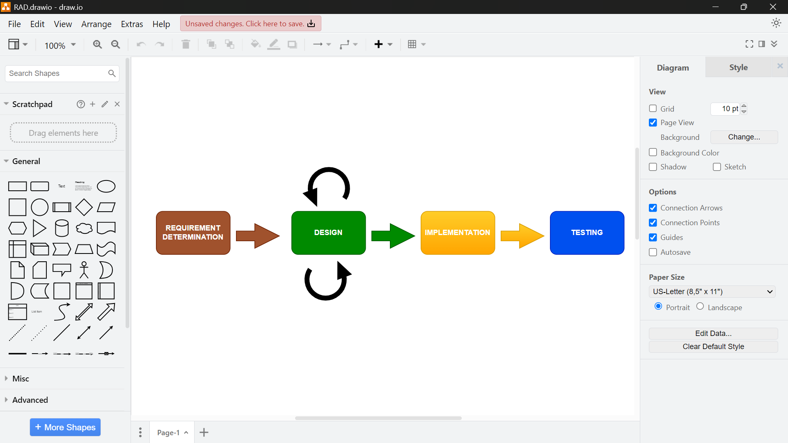
Figure 1: Rapid Application Development Process
The research design provides a structured plan for data collection and interpretation, which guides the system’s architecture and functionality. Other visual tools to be employed include:
- System Architecture Diagram – Provides a structured layout and behaviour of system components, illustrating how students, lecturers, and administrators interact with the FYPMS while ensuring scalability and alignment with Busitema University’s academic model.
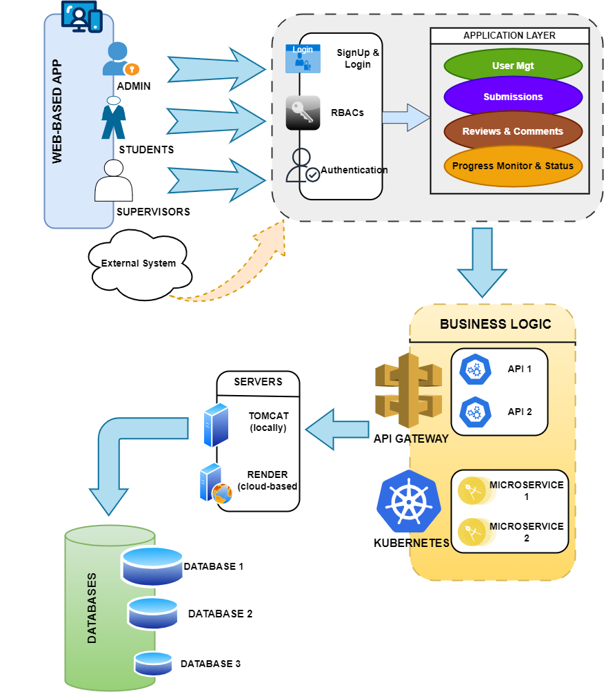
Figure 2: Final Year Project Management System Architecture.
- Context Diagram – Offers a high-level view of system interactions with external entities, helping to define system boundaries and the flow of information between the FYPMS and stakeholders such as students, lecturers, and administrators.
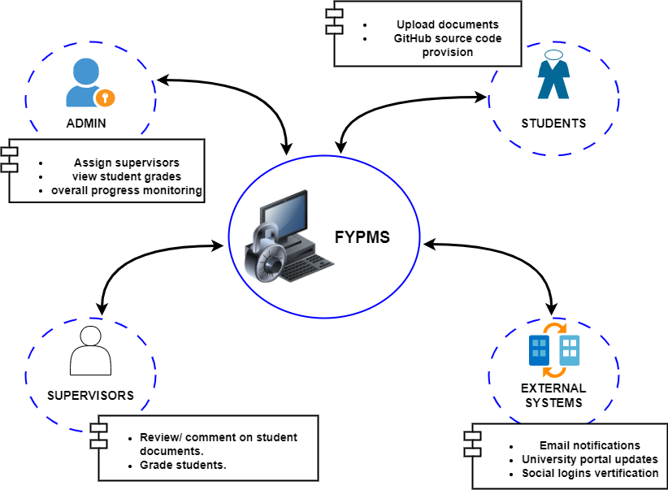
Figure 3: Final Year Project Management System Context Diagram.
- Data Flow Diagram (DFD) – Depicts internal system processes in detail, including supervisor assignment, proposal and report uploads, and GitHub repository invitations. DFDs guide the development of efficient data pathways within the system.
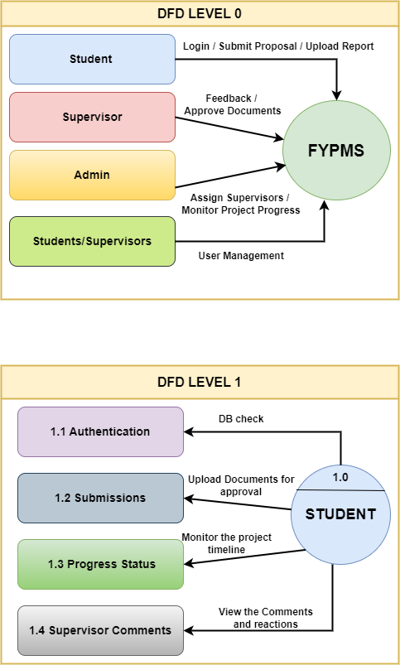
Figure 4: Final Year Project Management System Data Flow Diagrams.
- Use-Case Diagram – Models the various functions that users will perform within the system:
  - Students: Submit proposals, upload reports, track project progress.
  - Supervisors: Provide feedback, approve submissions, manage and view assigned students.
  - Administrators: Manage users, monitor project progress, assign supervisors.
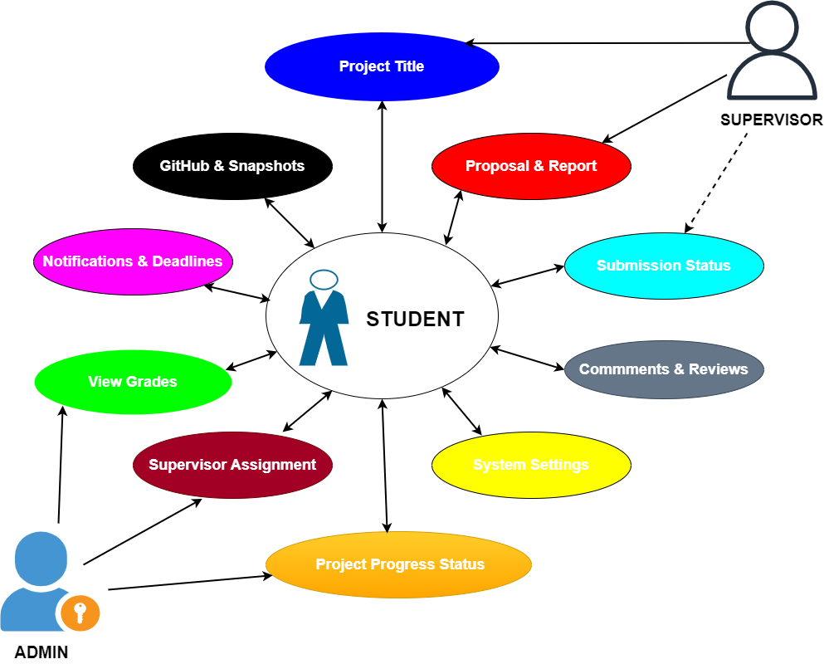
Figure 5: Final Year Project Management System Use-Case Diagram.

System Software Implementation and Tools
The FYPMS will be a web-based system with a cloud-hosted backend. The system will be implemented using the following tools:
- Operating System: Windows OS, which manages hardware and software resources and provides an environment for software development and deployment.
- Integrated Development Environments (IDEs):
  - Visual Studio Code: For front-end development and web technologies.
  - IntelliJ IDEA: For backend Java (Spring Boot) development, offering features such as code editing, syntax highlighting, auto-completion, code refactoring, layout editing, and device debugging.
- Web servers: An inbuilt web server known as Tomcat Server in the IntelliJ IDEA which runs at port 8080. Also additionally, for cloud hosting Render will be deployed. GitHub Pages to host the static pages.
- Web browser: Google chrome will be the most ideal browser to access the web pages and technologies.
- Frontend technologies: Markup languages like HTML and CSS and also including scripting languages like JavaScript are to be used.
- Backend technologies: Spring Boot, a Java framework is to be used to build the business logic and handle API calls.
- Database: An open-source relational database management system that organises data into one or more tables. That is PostgreSQL.

Testing and Validation
The developed system will undergo rigorous testing and validation to ensure full functionality, performance, and alignment with user needs.
- System Testing – Evaluates the entire integrated system to ensure compliance with functional and system requirements. Testing will include:
  - Ensuring mandatory fields cannot be left empty.
  - Verifying accurate responses for correct and incorrect input data.
- Validation – Confirms that the data entered into the system meets pre-defined formats, length, character restrictions, and other input criteria (e.g., proper email formatting). Sample data will be used to test the system’s response to valid and invalid entries.
- Unit Testing – Focuses on individual features such as login, content upload, and assignment submission.
- Integration Testing – Ensures seamless interaction between modules, validating complete workflows and proper data flow.
- Validation Testing with User Feedback – Assesses whether the system meets the identified requirements and collects user feedback to refine usability, interface design, and overall system performance.
By the end of the validation phase, the FYPMS will be fully functional and ready to enhance educational delivery at Busitema University, addressing current limitations in final year project management, improving administrative and academic operations.

References
Alruwais, N., Wills, G., & Wald, M. (2018). Advantages and challenges of using e-assessment. International Journal of Information and Education Technology, 8(1), 34–37.
Ahmad, I., 2024. Evaluation of the implementation of Educational Management Information Systems in supporting strategic decision-making in higher education. Contemporary Journal of Applied Sciences, 2(6). Available at: https://doi.org/10.55927/cjas.v2i6.12314.
Haruna, I.U., Awang, H., Mansor, N.S., Ibrahim, H.H., Azni, S. and Khamis, S., 2023. Prototyping a web-based application for remedial education data management. Sinergi International Journal of Education, 2(2). Available at: https://doi.org/10.61194/education.v2i2.256.
Kebebe, M. and Regassa, T., 2024. An empirical research on the practices of EMIS in South West Showa education sectors. American Journal of Education and Information Technology, 8(2), pp.69–72. Available at: https://doi.org/10.11648/j.ajeit.20240802.11.
Masruri, M.N., 2025. Conceptual analysis of Educational Management Information Systems for optimizing the learning process. JEDMI: Journal of Education and Multidisciplinary Studies, 1(1), pp.11–21. Available at: https://journal.megantaraabdinusa.org/index.php/jedmi/article/view/58
Suharno, F.S. and Imraan, M., 2024. Development of a website-based project management information system. The International Journal of Education Management and Sociology, 3(2), pp.67–77. Available at: https://doi.org/10.58818/ijems.v3i2.117.

APPENDICES
Appendix A: Project Budget
This appendix presents the estimated cost of developing the Final Year Project Management System.
Estimated Budget Table
ITEM | DESCRIPTION | ESTIMATE COST (UGX)
Stationery | Printing, photocopying, binding | 80,000
Data Collection | Transport, airtime, internet | 120,000
Software Tools | VS Code, IntelliJ (free), GitHub (free) | 0
Internet | Research, development, testing | 150,000
Hosting (Testing) | Free tire (GitHub Pages, Render) | 0
Contingency | Unexpected expenses | 50,000
Total Estimated Cost |  | 400,000

Table 2: Table of Estimated Budget costs.

Appendix B: Work Plan & Timeline
This appendix contains work plan and a timeline on how the project will be carried out over a period of five months starting from 17th October, 2025 to February 2026. Activities will be executed sequentially, beginning with proposal writing and literature review, followed by system analysis, design, implementation, testing, documentation, and final submission by 28th February 2026.
ACTIVITY | OCT | NOV | DEC | JAN | FEB

Proposal Writing
Literature Review
Requirement Analysis
System Design
System Implementation
Testing & Validation
Documentation
Final Submission

Table 3: Table of Activity Timeline
Period of activity

Appendix C: Guide Questions
This appendix contains the guiding questions used during interviews with students, supervisors, and administrators. Questionnaires, observation and literature view questions are also included.
Interviews (Students, Supervisors, Administrators)
Guiding Questions:
- How are final year projects currently managed at the University?
- What challenges do you face in supervising or submitting final year projects?
- How do you track project progress and milestones?
- What delays are commonly experienced during project supervision?
- What features would you expect in an automated project management system?
- How do you currently store and retrieve project documents?
Questionnaires (Mainly Students)
Guiding Questions:
- How do you currently submit your project proposals and reports?
- How often do you receive feedback from your supervisor?
- What challenges do you face during project supervisor?
- Do you experience delays in proposal approval or grading?
- Would you prefer an online system for managing final year projects? (Yes/No)
- What features would you find most useful in such a system?
Observation
Observation Checklist:
- How students submit proposals and reports
- Time taken to receive supervisor feedback,
- Communication methods used between students and supervisors
- Record-keeping practices (manual files, emails, logbooks)
- Challenges faced during submissions and approvals
Literature Review
Guiding Focus Questions:
- What existing systems are used to manage final year projects in universities?
- What challenges are associated with manual project management systems?
- What technologies are commonly used in FYP management systems?
- What best practices exist for supervising student projects digitally?

